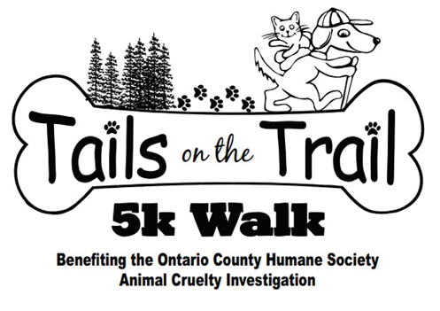

***5th Annual***





**Saturday, April 28th**

**Finger Lakes Technical and Career Center Check-in & Registration at 9:00 – 9:45 a.m.**

**Walk starts at 10:00 a.m.**

C:\Users\Marina.Bartolotta\AppData\Local\Microsoft\Windows\Temporary Internet Files\Content.IE5\W91QPZHZ\bi[1].jpg

**Food**

**&**

**Drinks**

**

**How to Register:**

[www.ontariocountyhumanesociety.org/tailsonthetrails.html](http://www.ontariocountyhumanesociety.org/tailsonthetrails.html)

In person at Happy Tails

Mail in Registration Form and Fee

Morning of the Walk

**$25 registration fee**

***Farm to Table SAA* Plant Sale**

**Rescue Organizations on site**

***Hosted by the FLTCC Animal Science Class partnering with Criminal Justice and Farm to Table SAA***

**Raffle Baskets & Vendors**

**Microchip Clinic!**

**Presented by PMAR**

**$15 fee**

**Raised Dog Bed to be Raffled Off!**

**Canine Demonstrations**